

Homework 3

solutions



Members

2019380183 Mike Yondela

2019380141 ABID ALI

2019380135 MATMUSAEV DONIYOR

1. Using the python programming to calculate the following project activities’ early start time, early finish time, late start time, late finish time, total slack, free slack, and determine the critical activities.

* actnum = 32 #32 activities in the project, the activity index starts from 0 ends with 31, activities 0 and 31 are dummy activities with 0 duration.
* duration = np.array([0,9,5,9,10,8,1,10,6,3,9,10,4,2,4,10,9,9,10,1,7,9,5,5,3,8,4,2,1,7,8,0], dtype=np.int32)
* succ = [[1,2,3],[4,9,10],[6,12,17],[5,8,15],[14],[7,11,16],[21],[13],[21],[13,28,30],[20],[29],[15,24],[24],[18],[19,25],[22],[21],[20,22],[23],[27],[24,28],[29],[27,30],[25],[26],[27],[29],[31],[31],[31],[]]

Hints: I already give some code for this problem, you should finish the cpm() function, this function should return the early start time, early finish time, late start time, late finish time, total slack, free slack, and critical activities of the project. The main function will print the results.

1. Using the python programming to simulate the project (task 1) duration.

* number=10000
* Activity duration follows beta(a, b, 3-, 3+), a=0.8*activity_duration, b=1.4*activity_duration.

Give the histogram of the project duration. Calculate the probability that the project can be finished before 54days.

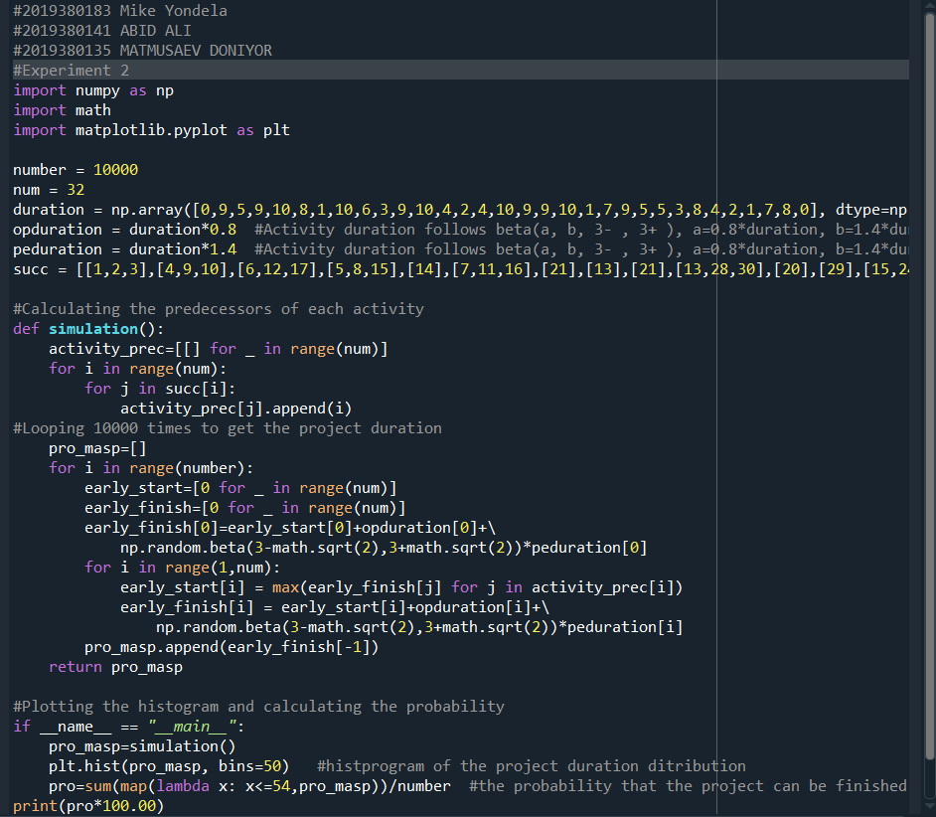

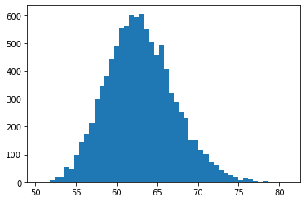

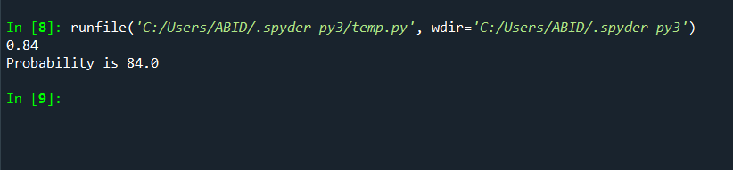

3、Using the python programming to simulate the project (task 1) duration, and analyze the schedule risk, calculate the Criticality Index and Cruciality Index(Using the Pearson’s product moment correlation) of each activity.

Hints: I already give some code for this problem, you should finish the riskanalysis () function, this function should return the Criticality Index and Cruciality Index of each activity.

Requirement:

For the first problem you should send me the code (.py document), and give the python calculating results in a table.

|  |  |  |  |  |  |  |  |  |
| --- | --- | --- | --- | --- | --- | --- | --- | --- |
| **Activity** | **Early start** | **Early finish** | **Late start** | **late finish** | **Free slack** | **total slack** | **Critical activity(0/1)** | |
| **0:** | 0 | 0 | 0 | 0 | 0 | 0 | 0 |  |
| **1:** | 0 | 9 | 4 | 13 | 0 | 4 |  |  |
| **2:** | 0 | 5 | 6 | 11 | 0 | 6 |  |  |
| **3:** | 0 | 9 | 0 | 9 | 0 | 0 | 0 |  |
| **4:** | 9 | 19 | 13 | 23 | 0 | 4 |  |  |
| **5:** | 9 | 17 | 9 | 17 | 0 | 0 | 0 |  |
| **6:** | 5 | 6 | 19 | 20 | 9 | 14 |  |  |
| **7:** | 17 | 27 | 17 | 27 | 0 | 0 | 0 |  |
| **8:** | 9 | 15 | 14 | 20 | 0 | 5 |  |  |
| **9:** | 9 | 12 | 24 | 27 | 12 | 15 |  |  |
| **10:** | 9 | 18 | 28 | 37 | 15 | 19 |  |  |
| **11:** | 17 | 27 | 36 | 46 | 19 | 19 |  |  |
| **12:** | 5 | 9 | 18 | 22 | 0 | 13 |  |  |
| **13:** | 27 | 29 | 27 | 29 | 0 | 0 | 0 |  |
| **14:** | 19 | 23 | 23 | 27 | 0 | 4 |  |  |
| **15:** | 9 | 19 | 22 | 32 | 0 | 13 |  |  |
| **16:** | 17 | 26 | 32 | 41 | 7 | 15 |  |  |
| **17:** | 5 | 14 | 11 | 20 | 1 | 6 |  |  |
| **18:** | 23 | 33 | 27 | 37 | 0 | 4 |  |  |
| **19:** | 19 | 20 | 38 | 39 | 0 | 19 |  |  |
| **20:** | 33 | 40 | 37 | 44 | 4 | 4 |  |  |
| **21:** | 15 | 24 | 20 | 29 | 0 | 5 |  |  |
| **22:** | 33 | 38 | 41 | 46 | 8 | 8 |  |  |
| **23:** | 20 | 25 | 39 | 44 | 0 | 19 |  |  |
| **24:** | 29 | 32 | 29 | 32 | 0 | 0 | 0 |  |
| **25:** | 32 | 40 | 32 | 40 | 0 | 0 | 0 |  |
| **26:** | 40 | 44 | 40 | 44 | 0 | 0 | 0 |  |
| **27:** | 44 | 46 | 44 | 46 | 0 | 0 | 0 |  |
| **28:** | 24 | 25 | 52 | 53 | 28 | 28 |  |  |
| **29:** | 46 | 53 | 46 | 53 | 0 | 0 | 0 |  |
| **30:** | 25 | 33 | 45 | 53 | 20 | 20 |  |  |
| **31:** | 53 | 53 | 53 | 53 | 0 | 0 | 0 |  |

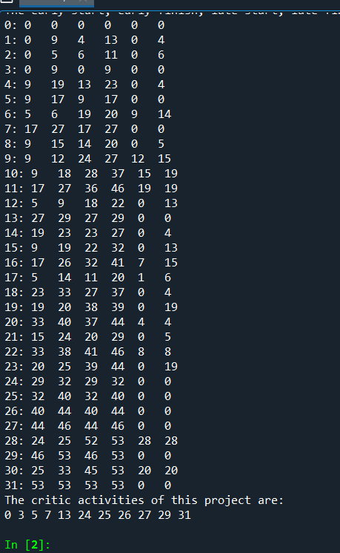

For the second problem you should send me the code (.py document), and give the histogram and the probability.

For the third problem you should send me the code (.py document), and give the Criticality Index and Cruciality Index of each activity.

|  |  |  |
| --- | --- | --- |
| Activity | Criticality Index | Cruciality Index |
| 0 | 61.7594 |  |
| 1 | 64.8939 |  |
| 2 | 62.7645 |  |
| 3 | 54.9948 |  |
| 4 | 62.3478 |  |
| 5 | 62.3821 |  |
| 6 | 63.4945 |  |
| 7 | 66.0438 |  |
| 8 | 64.0040 |  |
| 9 | 60.0147 |  |
| 10 | 62.5754 |  |
| 11 | 57.7469 |  |
| 12 | 63.9440 |  |
| 13 | 58.2559 |  |
| 14 | 65.0985 |  |
| 15 | 64.2770 |  |
| 16 | 63.6047 |  |
| 17 | 64.7671 |  |
| 18 | 59.0672 |  |
| 19 | 64.6914 |  |
| 20 | 57.2724 |  |
| 21 | 62.5947 |  |
| 22 | 61.3405 |  |
| 23 | 57.5976 |  |
| 24 | 61.5902 |  |
| 25 | 58.1149 |  |
| 26 | 60.3070 |  |
| 27 | 64.5722 |  |
| 28 | 72.7874 |  |
| 29 | 61.0845 |  |
| 30 | 59.2397 |  |
| 31 | 60.3901 |  |

